Eval Screenshots

Pawn Structure, other pieces material only:

* 10k test cases

Considering both players

100k test set:

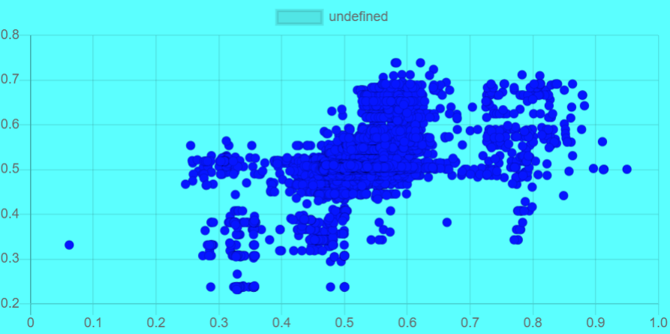

Still 100k test cases:

* 50 input in hidden layer

Still 100k:

* Lowering learning rate (0.2)
* 200 iterations
* 30, 20 hidden layers

